Operations Coordinator

Application pack

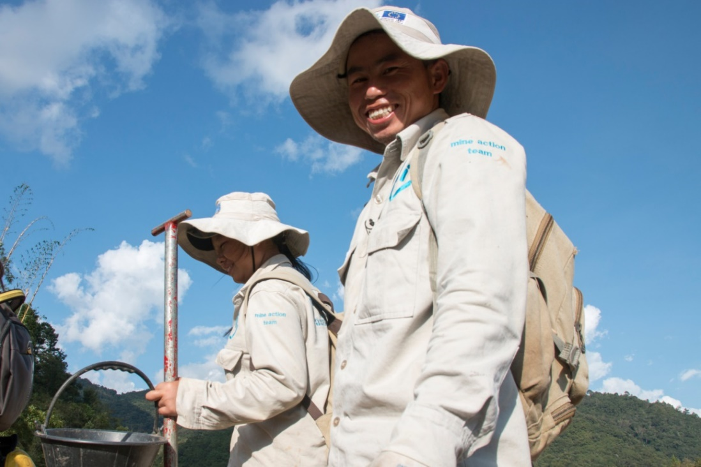

HI de-miners in Houaphan Province, Laos ©N.Lozano Juez/HI

Do you want to improve the lives of people with disabilities and vulnerable people?
Humanity & Inclusion (HI) is an award-winning international humanitarian and development organisation. Working alongside people with disabilities and vulnerable populations, we take action and raise awareness in order to respond to their essential needs, improve their living conditions and promote respect for their dignity and fundamental rights.

Our UK team is looking for an enthusiastic and committed individual to join us as a Operations Coordinator. This is an exciting and varied role working across many areas of our operations. You will be regularly in touch with colleagues across the network, suppliers and partners. You will also get a chance to gain understanding of our operations in the UK and across the world. If this sounds like the next role for you, we’d love to welcome you to our friendly and dedicated team.

About Humanity & Inclusion (HI)

HI is co-winner of the 1997 Nobel Peace Prize for its work on the Mine Ban Treaty. We were also awarded the 2011 Hilton Humanitarian prize in recognition of our contribution to alleviating human suffering and supporting the most vulnerable people.
Grace, 5, was born with a congenital disability. She lives in Kakuma refugee camp. Having received a prosthesis from HI, she goes to school and can play like any other child. She wants to be a teacher when she grows up. Here she is with Stella, her HI physiotherapist.

©Patrick Meindhardt/HI

Outraged by the injustice faced by people with disabilities and vulnerable populations, we aspire to a world of solidarity and inclusion, enriched by our differences, and where everyone can live in dignity.

Respect for the rights of people with disabilities has been at the heart of HI’s approach since it was founded in 1982. Over forty years on, our organisation is still working and fighting around the world to improve the living conditions of people with disabilities and other vulnerable people and to ensure that their fundamental rights are respected.

About Humanity & Inclusion UK (HI UK)

HI UK is a member of the Humanity & Inclusion Network, which is comprised of a Federation and eight national associations. As part of the Network, HI UK works towards a common strategy while maintaining a distinct identity as a British organisation. The Federation is responsible for implementing the Network’s social missions in around fifty countries. It operates under the names “Humanity & Inclusion” or “Handicap International”, depending on the country.

HI has an ambitious delivery plan in the UK, as part of our 2016-25 strategy, For More Solidarity and Inclusion in the World.

Equal opportunities policy

HI UK is committed to diversity and inclusion. We recognise that discrimination shapes the opportunities that many people have in society and that people have different needs in order to realise their full potential. Addressing this requires organisations to be proactive in creating environments that encourage the inclusion and development of all. Though we still have a long way to go, inclusion is central to our identity at HI UK and we are strongly committed to the continuous work that it requires.

We are particularly interested in hearing from candidates with disabilities and/or from Black and minority ethnic backgrounds, to help make us more representative. If you have a disability and meet the minimum requirements for the role, we will guarantee you an interview.

Employee Benefits

- All employees are entitled to 28 days’ holiday per year in addition to UK public holidays (pro rata for part-time employees). Colleagues may also take an additional day off for their birthday.

- Training and development opportunities are open to all staff and will be provided in order to support them to fulfil their roles.

- We value all our employees and strive to support them in their professional lives. This includes offering flexible-working opportunities, including home-working, flexible hours and two days’ volunteering leave each year.

- We offer a competitive workplace pension scheme, matching contributions up to 6% of gross salary.

- We are positive about employing persons with disabilities and are proud to be accredited as a Disability Confident Leader.

- We offer a Worklife Support Employee Assistance Programme, which provides confidential information, support and counselling.

- We strive to create a diverse and inclusive working environment and we are constantly looking at ways to improve our policies, processes and culture.

- Our office is conveniently located in SE1 with great transport links to Waterloo, Charing Cross, London Bridge and the London Underground. We run a hybrid-working approach, with colleagues expected to work from the office at least six days a month.

JOB DESCRIPTION

1. JOB TITLE Operations Coordinator

2. ORGANISATION Humanity & Inclusion UK (HI UK)

3. SALARY £30,955 per annum

4. REPORTING TO Chief Finance and Operating Officer

5. DURATION 12 months (maternity cover)
Start date 1st July

6. LOCATION London (SE1) with some remote working
The applicant must have the right to work in the UK

7. BACKGROUND INFORMATION AND PURPOSE OF THE POST

The Finance and Resources Team is responsible for responsible for HI’s finances, general services and HR in the UK. It comprises the Chief Finance and Operating Officer, a Finance Officer and an Accounting Officer.

The main purpose of this post is:

- To ensure smooth and efficient running of the HI UK office, including office services, IT, internal communications and health & safety
- To act as a key point of contact within the organisation and externally
- To undertake human resources administration for staff and volunteers, including supporting recruitment and follow-up
- To provide administrative support to the Chief Executive, Leadership Team and Board of Trustees

9. MAIN DUTIES AND RESPONSIBILITIES

Operations
- Maintain the office facilities and environment to agreed service levels
- Act as primary point of contact with the landlord and all suppliers for the office space, proactively dealing with arising issues
- Be responsible for the operation and maintenance of office equipment and IT equipment for all staff and volunteers, and arrange their repair or replacement, in conjunction with the Finance Officer and the Accounting Officer, as need arises
- Act as principal contact person for HI UK’s IT infrastructure and support provider, helping colleagues to access IT support when required and developing and implementing the organisation’s IT strategy
- Manage budget lines associated with running of the office and participate in procurement, primarily of office and IT supplies, liaising with external suppliers.
- Act as designated Health & Safety Officer for the office, including ensuring Health & Safety policies are up to date and being adhered to
- Continually review systems in place within the office, make improvements where required, and communicate these to relevant people

Human Resources
- Provide administrative support and advice for the recruitment of staff, consultants and volunteers, including advertising, interviews, issue of contracts and inductions, liaising with the federation manager and recruitment teams when relevant
- Assist with other HR tasks, including managing staff and volunteer files, managing the HR information system, administrative support for payroll and contributing to updates of the staff handbook
- Support teams on volunteer recruitment, contracts, induction, support and training
- Maintain an up-to-date welcome kit for new starters and provide and coordinate induction training sessions
- Make sure that HR policies and internal processes are updated and well known by all the staff
- Provide support and advice to managers on HR matters, in collaboration with the Chief Finance and Operating Officer and the Chief Executive, including leave management, payroll, pension, changes in contracts or situation, flexible working and flexible hours, diversity and inclusion, potential conflict and interpretation of the Staff Handbook

Administrative support
- Provide administrative support to the Chief Executive, including diary management, preparing and servicing meetings and filing
- Organise and support meetings of the Board of Trustees, including room booking, diary management, preparation of papers, minute-taking and organising catering
- Maintain filing systems
- Deal with enquiries, calls and emails from the public, partners and other HI entities
- Support specific projects as needed

Other tasks
- Contribute to projects led by the Finance and Resources team and the HI UK whole team.

Conduct and safeguarding

Respect and dignity of all the people we support and come into contact with are at the heart of HI’s approach. All employees, volunteers (including trustees), partners, suppliers and consultants working with HI UK are expected to adhere to our Code of Conduct and related policies.

Our commitment to safeguarding means we seek to ensure that no harm comes to people as a result of contact with the organisation’s programmes, operations or people. This means ensuring the safety and protection of groups, including children and vulnerable adults, with whom the organisation is in contact, establishing safe and respectful workplaces that are free from harassment, abuse and discrimination, and maintaining HI’s reputation and high standards by preventing, addressing and learning from instances of wrongdoing.

This post is Safeguarding Level 1, which means no DBS check is required (unless the content of the post changes).
HI is a member of the inter-agency Misconduct Disclosure Scheme (MDS). In line with the principles of this scheme when we contact your referees, we request that they provide information in relation to any findings of sexual exploitation, sexual abuse and/or sexual harassment (‘Misconduct’) during the candidate’s employment or any allegations of this kind that were under investigation at the point that the candidate left their organisation.

Accessibility

Our office is a short walking distance from Waterloo and Southwark stations. There are also lots of bus stops nearby. We share an open-space with other charities. The space is rather quiet but there are also bookable meeting rooms, booths for individual meetings, noise reduction pods, and other informal meeting spaces.

We have lifts, accessible toilets and kitchen area.

We are open to discuss any reasonable adjustments you might need.

9. PERSON SPECIFICATION

We genuinely value diversity, and are looking to build a team of people with a wide of range of personal and professional experience. If you don’t meet all of the criteria listed below, but feel you would be a good candidate for this role, please apply. If you would like an informal conversation about this, please do send us an email or call us – we would love to hear from you.

ESSENTIAL CRITERIA
- Proven experience of managing core office services such as health and safety, infrastructure, IT etc
- Excellent interpersonal communication and customer-service skills
- A can-do attitude and willingness to contribute to the team
- Strong multi-tasking skills and capacity to prioritise
- Strong planning and organisational skills
- Experience of administration and procurement, including dealing with suppliers
- Excellent attention to detail
- IT literacy (MS Office suite, Wi-Fi, laptops and printers)
- Ability to work discreetly and with sensitive information
- Good written and spoken English
- Passion for improving the lives of the world’s most vulnerable people
- Commitment to creating and maintaining an inclusive and protective environment for everyone that comes into contact with the organisation

DESIRABLE CRITERIA
- IT network support skills
- Experience acting as designated health & safety officer
- Experience of human resources administration
- Experience in managing budgets
- Good spoken French, with comprehension of spoken and written French
- Experience of working in an international multi-cultural charity/organisation
- Lived experience of disability or from one of our countries of operation

APPLICATION PROCESS

To apply, please send your CV and a covering letter by email or post. Please also complete our Diversity monitoring form online.

By email: recruitment.uk@hi.org
By post: Humanity & Inclusion UK (Recruitment), Romero House, 55 Westminster Bridge Road, London, SE1 7JB.

If you disclose a disability during your application process and you meet the minimum criteria for the role, we will contact you to discuss any reasonable adjustment you might need at the interview. However, if you have not disclosed, please be aware that any candidate invited for interview will be asked if any reasonable adjustments are needed.
If you wish to disclose a disability please do so in your covering letter.

Closing date: 8th May 2024
Remote interviews are planned for the week commencing Monday 13th May.

For further information, please contact Humanity & Inclusion UK on 0870 774 3737 or by email at recruitment.uk@hi.org.

